Table of Contents

1 Accessing the environment 3

2 Introduction to Smart Topics 4

2.1 Setting up our Environment 4

2.2 TOPICS 101 6

2.3 Hands On with AEM and Topics 7

3 AEM and Queues 12

4 Setting the stage - Business case scenario #1 13

4.1 Hands-on: Set up packages within Integration Suite, cloud integration 15

5 Hands-on: Publish Business Partner Changed events to Salesforce 19

5.1 Overview of iFlow 19

5.2 Create required queues and subscriptions for Salesforce iFlow 19

5.3 Obtain AEM Broker Connection Credentials 21

5.4 Security Configuration 22

*5.5* Configure and Deploy BusinessPartnerChange_SF_AC221536U*??* 22

5.6 Test the BusinessPartnerChange_SF_AC221536Unn iFlow 25

6 Setting the stage - Business case scenario #2 26

7 Scenario 2 – Publish Business Partner Changed events to Coupa 27

7.1 Create required queues and subscriptions for Coupa iFlow 27

*7.2* Configure and Deploy BusinessPartnerChange_CO_AC221536U*nn* 28

7.3 Test the BusinessPartnerChange_CO_AC221536Unn iFlow 30

8 Optional: Understanding Retry, Error handling, unblocking message processing – If time permits 31

8.1 Adapter settings 31

8.2 Queue configuration for retry handling 32

9 Appendix – Connecting to the TRY ME utility 35

9.1 Obtain connection credentials 35

# Accessing the environment

**Please use incognito / private mode to connect** … otherwise, there  could be confusion with existing SAP users and you may end up in somebody else’s environment!

**AEM**

<https://eu10.console.pubsub.em.services.cloud.sap/login?tenant-id=47ad3afc-3d8a-4dca-85bb-6cce8ebae9e3>

**Integration Suite**

<https://integration-suite-us10.integrationsuite.cfapps.us10-002.hana.ondemand.com/>

Participant User ID:

AC221536U***nn(Replace “nn” with your userID)***

Email: [AC221536Unn@sapexperienceacademy.com](mailto:AC191299Unn@sapexperienceacademy.com)

Password: **<<<Instructors will provide this during the hands-on exercise>>>**

The **AEM instance** that will be used is “**broker for EDA demo**”

# Introduction to Smart Topics

## Setting up our Environment

**\*\*\*THIS NEXT SECTION IS FOR INFORMATIONAL PURPOSES ONLY, IT’S ALREADY BEEN DONE FOR YOU FOR THE WORKSHOP\*\*\***

In the environment today, we will be simulating a typical customer setup where we want to have Events that originate from an SAP System like S/4 or ECC published to the Advanced Event Mesh. This allows customers to then react in real time to these events with services like SAP Business Process Automation or Cloud Integration in real time.

The pattern that we suggest to customers is the Micro Integration Pattern where interfaces are established without any knowledge of the applications that will consume them. In the diagram below, you can see that the destination for our events is the Advanced Event Mesh(aka AEM). Events like Business Partner Create and Change will be published to the AEM without any knowledge of which or how many applications will be using that event. This makes the integration much easier to implement as you do not require knowledge of the consuming applications.

In our setup for the workshop, we will be using an Event Generator that will already be connected to the broker that you are using today but in case you would like to use it for your own testing, we will include the instructions here for how to access it.

We start by heading to the site <http://feeds.solace.dev>.

From this layout, you can see many feeds that you can experiment with but for the workshop, we will be using the SAP ERP Feed.

When you click into it, you will see the option to connect to a broker.

**\*\*\*YOU DON’T NEED TO DO THIS FOR THE WORKSHOP, IT IS ALREADY CONNECTED\*\*\***

For the connection details, you will take your broker connection details for the WebMessaging protocol and provide them here. Once you are connected, you can then select the Events you would like to test.

For the workshop, we have activated the Business Partner Change and the Business Partner Create and this will be the 2 events that we are “simulating” from an ERP perspective.

For example, if you had a website or vendor portal that allows your customers to change their address for example, you might want to publish that Address Change as an event so you could send that customer an immediate email to confirm the change was made and the address reflects accurately what the customer wanted. For the purposes of the workshop, we will now use this setup to help you understand how to subscribe dynamically to this information coming out of SAP.

## TOPICS 101

As we walk into the next section, it’s useful to understand the basic structure of a topic and how it should be constructed. As you can see in the diagram below, our best practices suggest using a “NOUN”, followed by “VERB” and (eg.SALESORDER/CREATED) then a set of properties that you choose depending on how you would like to access the data later. The noun and the very are typically fixed and/or static and the properties that follow the static portion are usually populated at runtime.

So, in the base of our example below all events published related to business partner would have the first section of their Topic as “sap/erp/businesspartner/create/v1” as the static portion and what follows would be the dynamic properties.

Properties for a business partner could include city/state/zip code, lat, long, etc…this would allow you to later subscribe and filter on customers in a certain city or geographic location as 2 easy examples.

Additionally, the Advanced Event Mesh service allows you to also use wildcards which will be seen below.

## Programmer female with solid fillHands On with AEM and Topics

### Introduction to Wild Cards

Your first challenge will be to create a subscription to the Advanced Event Mesh that will attract any Business Partner that has been created or changed.

The events that are being generated from the Simulator have the following topic structure:

**sap/erp/businesspartner/change/V1/{businessPartnerType}/{partnerId}**

**sap/erp/businesspartner/create/V1/{businessPartnerType}/{partnerId}**

In your first challenge, you will want to use the TRY ME tab on the broker to connect and create a subscription that will show you all created or changed Business Partners. For this we will introduce 2 wildcards:

‘*’ is used to match pieces of data at a certain level. For example, if I wanted all events that matched any Version number I could create a subscription that looks like this:

**sap/erp/businesspartner/change/*/Executive/50**

**So in this case, you can see below the topic structure and we have placed “*” in the position where the Version number would appear.**

**sap/erp/businesspartner/change/V1/{businessPartnerType}/{partnerId}**

So in this case, the asterisk is being used to attract events that have any version number and also just Executives with the ID of 50. Important to note that the asterisk only matches that level.

**‘>’** is used to match any and all levels that follow it.

**sap/erp/>**

So in this case, a subscription like this would attract any and all events that have a topic starting with sap/erp and it would match all business partners, sales orders, purchase orders, etc…

The interesting thing is that you can use these in combination with each other so you can have something like:

**sap/erp/*/change/>**

What exactly would this Subscription attract?

Hands-on exercise – Use “>” wildcard filter expression

Exercise 1

* Navigate to the Try-Me tab
* Use the “>” wildcard filter in the subscription window
* What events do you expect to see?
* Detailed instructions to complete this exercise are given below

Navigate to the “TRY ME” tab to try our First Subscription which will attract any Business Partner that has been created or changed in the SAP System. Use the instructions contained in the Appendix to connect and return here Appendix – Connecting to the TRY ME utility

For starters, lets understand how to use the wild card to subscribe to every single event coming into the AEM service.

Once you have successfully connected to the TRY ME facility as per the instructions located in the Appendix, enter a “>” into the “Topic Subscriber” input box and press enter.

Once you have subscribed as shown in the next screenshot, you should immediately see events appearing in the window towards the bottom of the screen. If so, you have dynamically subscribed to the mesh and had your first experience with using a Topic Subscription. It’s REALLY important to recognize that the TRY ME tab is not doing the filtering here, is the AEM service. AEM is only sending events to your “Try Me” tab that match the subscription you have entered.

Hands-on exercise – Filter on “Business Partners”

 Exercise 2

* Navigate to the Try-Me tab
* Try to work out what filter expression you need to use to filter on business partners only!
* Detailed instructions (and answer) to complete this exercise are given below

So, now try to create a subscription that only attracts Business Partners that have been changed or created. Resist the temptation to look below this line and see the answer 😊

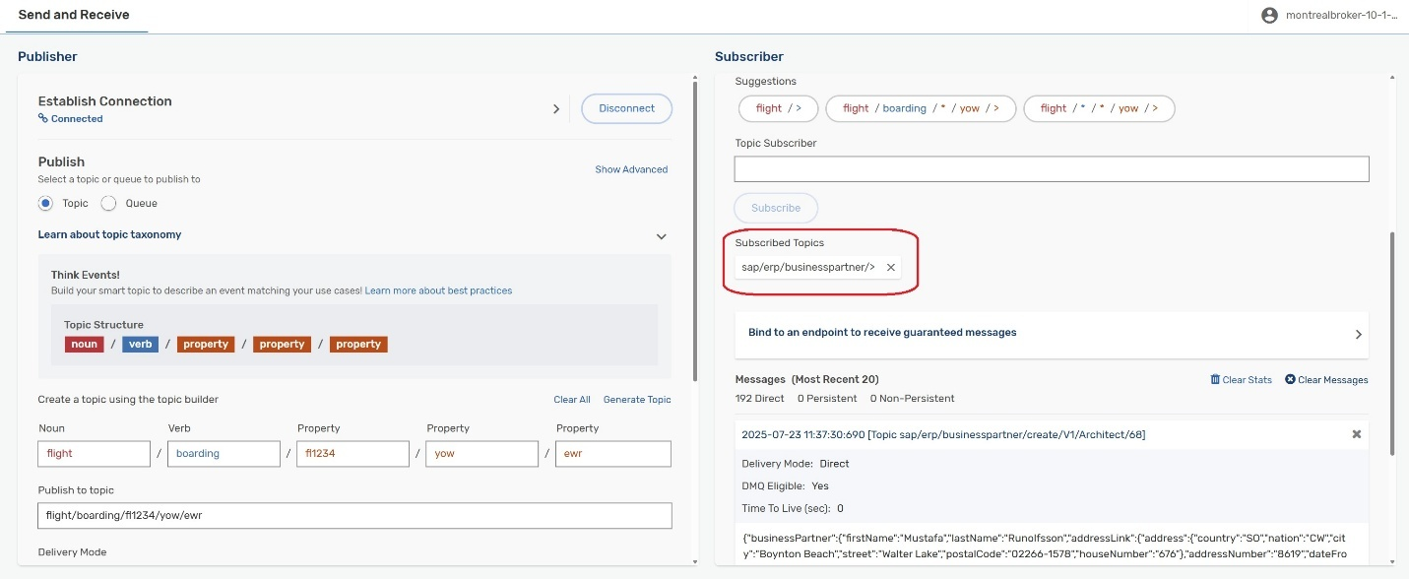

So, if you remove the previous subscription and enter a new subscription with this format :

sap/erp/businesspartner/>

You should see all created and changed business partners arrive in the window.

Hands-on exercise – Filter on “Developer Business Partner type”

 Exercise 3

* Navigate to the Try-Me tab
* Use the filter expression “sap/erp/businesspartner/change/V1/Developer/>” in the subscription window
* Detailed instructions to complete this exercise are given below

Create a subscription that only attracts Business Partners that have changed with a business partner type of “Developer”.

Now, if you remove the previous subscription and replace it with the following subscription:

sap/erp/businesspartner/change/V1/Developer/>

You should only see events coming into the Try Me window that are changed developer business partner records.

The use of Smart Topics allows you to filter/stream exactly the information you need and the filtering is handled completely by the AEM service so that filtering is not necessary on the client. This makes the construction of the Topic Taxonomy extremely important.

# AEM and Queues

Queues can be used by customers to ensure guaranteed delivery of messages in circumstances where delivery of messages might not be possible. For example, what if the target system has been shutdown for maintenance. For example, perhaps you have an application that needs to be updated with the new business partner record but it has been stopped for maintenance. Without taking the necessary steps, records could potentially be lost. This is one situation where Queues can be really helpful.

A Queue will be created and uses the same Subscription concept to pull the messages into a staging area and will persist them safely in order until the subscribing application is available to receive them. In cases like this, clients are consuming the events from the queue and not consuming based on Topics. This is an important concept and will be illustrated below as a way to guarantee delivery.

# Setting the stage - Business case scenario #1

**Objective:**

This hands-on workshop will guide you through a series of exercises designed to introduce the pattern of modern integration using the “Micro Integration” concept. The concepts presented here can be used by existing Integration Suite, Cloud Integration customers to facilitate and compliment their approach to integration.

We'll begin with a discussion around conventional integration design using SAP Integration Suite (iFlows), then illustrate how the EDA micro integration pattern can be used to bring an enhanced level of flexibility and agility to all future integration scenarios.

We believe you will quickly discover and understand why **event-driven architecture (EDA)** can be used with Cloud Integration to deliver better agility, scalability, and decoupling.

**Business Case Scenario:**

Business Requirement:

*Synchronize any updates made to a Business Partner record in SAP S/4HANA with Salesforce (SFDC).*

How Would You Approach This?

### **Traditional Approach** using an iFlow

** It should be noted that this is a simplified iFlow that does not include error handling or guaranteed delivery of the messages which would typically include a queuing mechanism.**

**Implementation Path:**

1. Use **SAP Integration Suite** to create an **iFlow**.
2. Connect to **SAP S/4HANA** via OData or IDoc adapter to fetch supplier updates.
3. Perform any necessary transformations.
4. Connect to **Salesforce** using the Salesforce adapter or REST API.
5. Push the updated record to Salesforce.

**Challenges:**

* Receiver is pre-determined when building the iFlow
* Retry logic will be created manually.
* Difficult to extend when new consumers (e.g., Coupa, Docusign, ServiceNow, data lake, compliance app etc.) need the same event.
* If used, polling mechanisms can create latency and load on the backend.
* If used, scheduled jobs will not deliver the information to the backend in a timely manner leading to out of sync 3rd party systems.

Today , we will be guiding you through the Micro Integration Approach. We will use event-driven integration approach that will help you build highly decoupled, scalable integrations across hybrid cloud environment.

S4 Hana natively produces events and there are several mechanisms that permit S/4 and ECC to publish full data events. So, any changes to the business partner can directly be published on Advanced Event Mesh (AEM) as an event. We will still build an iFlow, but this time it will be like a micro-integration (micro-service) that reacts to an event in real-time. With this approach, S4 is publishing the data to the Advanced Event Mesh and there is not pre-conceived notion about where that data will go. The result is that S4 Hana and Salesforce systems are now decoupled and if one system is down the other is not affected. You also get built-in shock absorber capability of AEM where sudden deluge of data from S4 Hana will not overwhelm your iFlow. The extra volume of data will simply be buffered on a queue on AEM and AEM will trickle feed records to the iFlow at the speed it can be processed.

### **Modern Approach** – Event-Driven Architecture (EDA)

With an approach that is using EDA via Micro Integrations, the Business Partner changes will be published to the Advanced Event mesh.

Second step is to have a Queue that is subscribing to the relevant changes that you want.

Third step is to use an iFlow that will subscribe to that Queue for all changes and take the appropriate action.

Loosely coupled, highly flexible and highly scalable. Now lets try it.

**Advantages:**

* Loose coupling of systems
* Real-time processing without polling
* Better observability and error isolation

Hands-on: Set up packages within Integration Suite, cloud integration

Exercise 4

* Access Cloud Integration Service (Integration Suite)
* Create your Integration Package
* Import iFlow templates
* Detailed instructions below

### Access the [SAP Integration Suite](https://integration-suite-us10.integrationsuite.cfapps.us10-002.hana.ondemand.com/shell/home) service and click on **Design** section in the left-hand menu. Now click on “**Integration and APIs” under Design -**

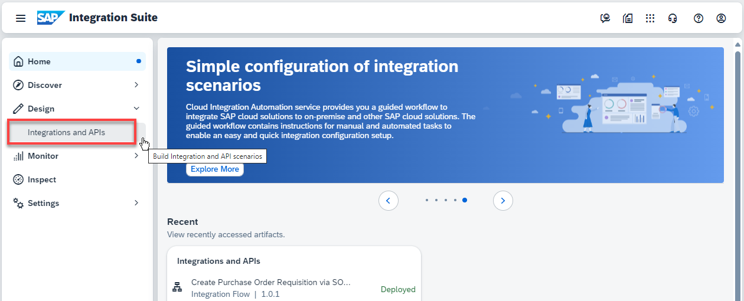

### Create the integration package

After clicking on “**Integration and APIs” you will see a “Design”** window on the right-hand side of the screen. This is where you will create your own package.

### Click on **Create** to create an integration package.

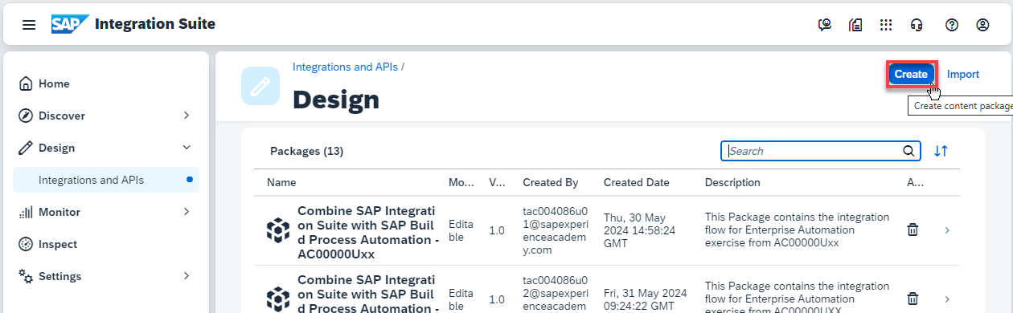

### Provide the following details:

* 1. Name: AEM_Workshop_AC221536U***nn*** where nn represents the last 2 digits of your userid
  2. Technical Name will be auto-filled with AEM_Workshop_AC221536U***nn***
  3. Short description: This package contains artifacts to process SAP Business Partner Updates.

### Click on Save once finished.

Within an integration package, you can add several artifacts: REST APIs, OData APIs, integration flows, mappings, and more. In our case, we will import templates for integration flows that will be used in the workshop.

### You will now **import** the iFlow templates **into your package** **from** the **templates package**

#### **Click on** Integrations and APIs -> Click on AEM_Workshop_AC221536Unn i.e. **the templates package**



#### Click on Artifacts -> Select one of the template iFlows (by clicking on the 3 dots)

#### Select the target package (your package e.g. AEM_Workshop_AC221536Unn) by clicking on “Select” see screenshot below:

#### Select your package; see screenshot below

#### Now type in the name of your iFlow in the Name field. For example, if you selected the BusinessPartnerChange_CO_AC221536U-- iFlow, you would type in BusinessPartnerChange_CO_AC221536U0155; *if 01 represents the last 2 digits of your userid*.

### Repeat the process for the other 2 template iFlows –

BusinessPartnerChange_CO_AC221536U--

BusinessPartnerChange_DS_AC221536U--

### You should now have 3 iFlows in your Integration Package. Let’s check.

Click on “Integrations and APIs” -> Click on AEM_Workshop_AC221536U***{your 2 digits}*** ->

Hands-on: Publish Business Partner Changed events to Salesforce

Exercise 5

* Create queues on AEM broker
* Add topic subscription to the queues
* Obtain AEM broker connection credentials
* Configure iFlow
* Deploy iFlow

In this exercise, you will *subscribe* to Business Partner Changed events published by SAP. To achieve this, define a topic on your AEM broker that will receive the relevant events being published and associate this topic with a queue so that all these events are attracted to that queue. Remember that we previously discussed topic to queue mapping in the 1st warmup exercise.

The iFlow you previously downloaded has most of the configuration already in place (so **you won’t have much typing to do!**). The iFlow uses the ***SAP AEM Adapter*** to read events from the queue on your AEM instance. Within the iFlow, an outgoing call will be made to Salesforce. We will show you the message getting to the Salesforce system and the successful response.

## Overview of iFlow

This iFlow receives Business Partner Change and Create events being published to the topics shown below. It processes the events by making a HTTP call to the Salesforce application (**a mock service**) . In this exercise, each of you will be publishing change events (and some of you are using the same broker.

***sap/erp/businesspartner/change/V1/>***

***sap/erp/businesspartner/create/V1/>***

## Create required queues and subscriptions for Salesforce iFlow

Go to [**Advanced Event Mesh Console**](https://eu10.console.pubsub.em.services.cloud.sap/) **->** **Cluster Manager** -> **{your service}** -> **Manage** -> **Queues** - to open the Broker UI  

Click on the **"+ Queue**" button to bring up the create queue dialog.

Provide the name as given (in the next sections).

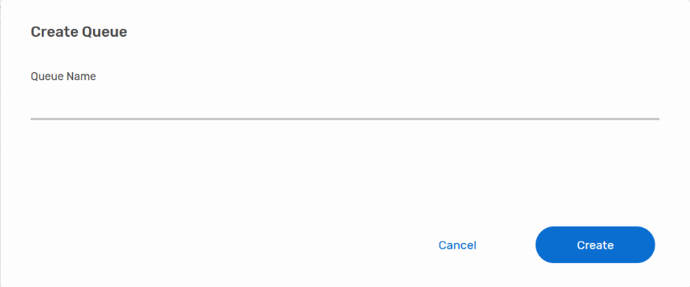

Create the following queue and provide the details as given (copy & paste where appropriate).

1. AC221536Unn_SF_IN queue

• Name: AC221536Unn_SF_IN

• Owner: solace-cloud-client

Once the queue is created, click on the queue name in the list, navigate to the Subscriptions tab and open the subscriptions dialog.

• For AC221536U*nn*_SF_IN, add the subscriptions:

***sap/erp/businesspartner/change/V1/>***

***sap/erp/businesspartner/create/V1/>***

## Obtain AEM Broker Connection Credentials

Before heading back to Integration Suite, let's head to our [Advanced Event Mesh Console](https://eu10.console.pubsub.em.services.cloud.sap/) and go to **Cluster Manager** -> **{your service}**. Select the connection point and protocol that you want to use to connect your Integration Suite flows by going to the "Connect" tab, order by protocol, then click on Solace Messaging. Make a note of the connectivity details underneath "Solace Messaging" (click on the section to open it up). We will need these details in the next steps when configuring your iFlows.

The connect tab lists all the various connectivity details for the various supported protocols. The SAP Integration AEM adapter uses Solace Messaging Format, which is AEM's very own protocol with a broad feature set support. [Solace Message Format](https://help.pubsub.em.services.cloud.sap/Messaging/SMF-Topics.htm?Highlight=solace%20message%20format) (SMF) is the underlying messaging protocol for SAP Integration Suite, advanced event mesh.

Each AEM service also comes with a default client user called solace-cloud-client that is configured for convenience reasons and is allowed to publish and subscribe to all topics. We will be using this user for all our iFlows.

## Security Configuration

**N.B. You only need to do this section (5.4) if you are using your own AEM broker rather than the one provided by the workshop. All this has already been done for those using the workshop provided broker.**

Rather than entering the AEM instance password directly on the iFlow and making it visible to everyone with access to the iFlow, we will create a SecureParameter which will store the password securely and we then just reference this in our iFlows.

Go to [Integration Suite](https://url.us.m.mimecastprotect.com/s/wPMHC82A5KuOzq37infOhy4FsV?domain=integration-suite-us10.integrationsuite.cfapps.us10-002.hana.ondemand.com) -> **Monitor** -> **Manage Security** -> **Security Material**.

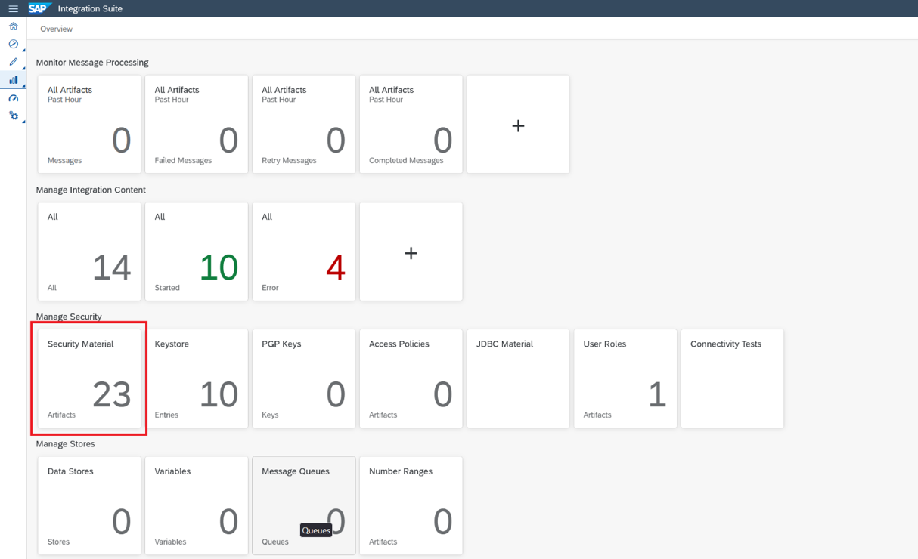

In here, create security credentials for your AEM broker service.

Create SecureParameter myBrokerUserPass and store the password for your solace-cloud-client application user credentials; nn represents the last 2 digits of your userid.

## Configure and Deploy BusinessPartnerChange_SF_AC221536U*??*

Navigate to the iFlow – Go to [Integration Suite](https://integration-suite-us10.integrationsuite.cfapps.us10-002.hana.ondemand.com/) -> Design -> Integrations and APIs -> AEM_Workshop_AC221536U*??* -> Artifacts -> BusinessPartnerChange_SF_AC221536U*nn*

### Configure AEM Adapter connection credentials

**N.B. You only need to do this section (5.5.1) if you are bringing your own AEM broker rather than the one provided by the workshop. All the pre-populated values for the iFlow should be correct for those using the workshop provided broker.**

Click on the configure button:

Click on the Sender tab and populate the connection credentials.

* Type in the AEM connection url you obtained from 5.3 above
* Type in the message vpn you obtained from 5.3 above
* Type in the Password Secure Alias you created from 5.4 above
* Click on Save
* Click on Close

### Edit the iFlow and add your queue name to the AEM Adapter configuration; **click on the AEM adapter arrow**.

1. Hit the Edit Button so that you can change the iflow
2. Click the “Dashed Line” that represents the connection to the receiver, which in this case is the AEM service.
3. Specify the Queue name where your messages are being stored.

### Amend Salesforce URL suffix for HTTP Adapter

To make sure your HTTP call gets to the correct destination (and to help identify individual requests in case of troubleshooting), amend the suffix to the endpoint for the HTTP call to the Salesforce (mock) service

/sf/AC221536U***nn(Replace “nn” with your userID)***

’sf’ is the identifier for the salesforce mock service

### Click on Save at the top right of the screen



### Deploy the iFlow



### Check on the Deployment progress

Make sure the iFlow goes to a Started state.

Go to [Integration Suite](https://integration-suite-us10.integrationsuite.cfapps.us10-002.hana.ondemand.com/) ->Monitor -> Integrations and APIs -> Manage Integration Content

## Test the BusinessPartnerChange_SF_AC221536Unn iFlow

Once everybody is ready, we will start the feeds again and events will start to flow to all your iFlows

We will show you your message being received by the Salesforce mock service.

You should also familiarise yourself with the error logs for when things don’t go quite so well!

Go to [Integration Suite](https://integration-suite-us10.integrationsuite.cfapps.us10-002.hana.ondemand.com/) ->Monitor -> Integrations and APIs -> Monitor Message Processing

For a successful response, you should see something like:

If you don’t get a response, check on the error logs for the iFlow in Integration Suite

Go to [Integration Suite](https://integration-suite-us10.integrationsuite.cfapps.us10-002.hana.ondemand.com/) ->Monitor -> Integrations and APIs -> Monitor Message Processing

Have a look at the logs and troubleshoot the error.

# Setting the stage - Business case scenario #2

**Business Case Scenario:**

Business Requirement:

*In addition to updating Salesforce, the business now requires that any changes made to a Business Partner (Supplier) record in SAP S/4HANA are also sent to****Coupa****, to ensure supplier profiles are accurately reflected in procurement workflows.*

How Would You Approach This Today?

### **Traditional Approach** – Point-to-Point (P2P) Integration

*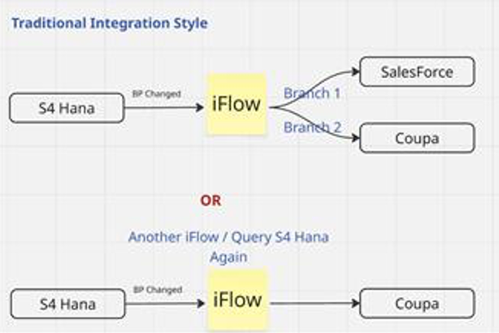***Implementation Path:**

* 1. You may extend your existing iFlow to also call **Coupa’s Supplier API**, or
  2. Build a **second iFlow** solely for Coupa

**Challenges Amplified:**

* Increased payload transformation complexity
* Error handling across systems becomes harder to manage
* Deployments take longer with every new consumer
* Adding a third or fourth downstream system (e.g., Data Lake, SAP Analytics Cloud, etc.) would require further duplication or chaining

Again, we are not going to use the P2P approach today, but we will use event-driven integration approach.

### **Modern Approach** – Event-Driven Architecture (EDA) – Seamless Expansion

**With SAP BTP Advanced Event Mesh (AEM):**

1. No changes are needed in the source system (S/4HANA continues publishing Business Partner events).
2. Coupa integration becomes just another subscriber.
3. You simply build a second event-consumer iFlow in Integration Suite for Coupa.

**Benefits Realized:**

1. Business logic for each consumer is encapsulated independently
2. No regression risk to Salesforce flow
3. Future systems (e.g., Compliance Monitoring, Risk Engines) can subscribe instantly without any changes to the event producer

# Scenario 2 – Publish Business Partner Changed events to Coupa

## Create required queues and subscriptions for Coupa iFlow

Go to [**Advanced Event Mesh Console**](https://eu10.console.pubsub.em.services.cloud.sap/) **->** **Cluster Manager** -> **{your service}** -> **Manage** -> **Queues** - to open the Broker UI

Click on the **"+ Queue**" button to bring up the create queue dialog.

Create the following queue and provide the details as given (copy & paste where appropriate).

1. AC221536Unn_CO_IN queue

• Name: AC221536Unn_CO_IN

• Owner: solace-cloud-client

Once the queue is created, click on the queue name in the list, navigate to the Subscriptions tab and open the subscriptions dialog.

• For AC221536U*nn*_CO_IN, add the subscriptions:

***sap/erp/businesspartner/change/V1/>***

***sap/erp/businesspartner/create/V1/>***

## Configure and Deploy BusinessPartnerChange_CO_AC221536U*nn*

Navigate to the iFlow – Go to [Integration Suite](https://integration-suite-us10.integrationsuite.cfapps.us10-002.hana.ondemand.com/) -> Design -> Integrations and APIs -> AEM_Workshop_AC221536Unn -> Artifacts -> BusinessPartnerChange_CO_AC221536Unn

### Configure AEM Adapter connection credentials

**N.B. You only need to do this section (7.2.1) if you are bringing your own broker rather than the one provided by the workshop. All the pre-populated values for the iFlow should be correct for those using the workshop provided broker.**

Click on the configure button:

Click on the Sender tab and populate the connection credentials.

* Type in the AEM connection url you obtained from 6.3 above
* Type in the message vpn you obtained from 6.3 above
* Type in the Password Secure Alias you created from 6.4 above
* Click on Save
* Click on Close

### Edit the iFlow and add your queue name to the AEM Adapter configuration; **click on the AEM adapter arrow**

### Amend Coupa URL suffix for HTTP Adapter

To make sure your HTTP call gets to the correct destination (and to help identify individual requests in case of troubleshooting), amend the suffix to the endpoint for the HTTP call to the Coupa (mock) service

/co/AC221536U***nn(Replace “nn” with your userID)***

’co’ is the identifier for the Coupa mock service

### Click on Save at the top right of the screen



### Deploy the Coupa iFlow

### Check on the Deployment progress of the Coupa iFlow

Make sure the Coupa iFlow goes to a Started state.

Go to [Integration Suite](https://integration-suite-us10.integrationsuite.cfapps.us10-002.hana.ondemand.com/) ->Monitor -> Integrations and APIs -> Manage Integration Content

## Test the BusinessPartnerChange_CO_AC221536Unn iFlow

Once everybody is ready, we will start the feeds again and events will start to flow to all your iFlows

We will show you your message being received by the Coupa mock service.

Notice that your salesforce iFlow will also have processed the message. Both Salesforce and Coupa are subscribing to the same topic and therefore receive the same data that is published.

# Optional: Understanding Retry, Error handling, unblocking message processing – If time permits

This exercise will demonstrate the benefits you get by adopting a publish/subscribe methodology even if you only have 1 downstream subscriber.

In this scenario, the downstream application becomes unavailable (we will arrange this). You will make some configuration changes to your queues to implement error/retry-handling and ensure that undeliverable messages do not block processing. All this without writing any code!

## Adapter settings

Let's take a look at some of the relevant AEM adapter settings that control this behaviour.

Let's look at these settings one by one:

1. **Acknowledgement Mode: "Automatic on Exchange Complete"**

The most important setting when it comes to not accidentally acknowledging and therefore removing a message from the broker's queue. This setting tells the flow/AEM adapter to only acknowledge (ack) the message after the flow has successfully completed processing the message. If any error in the processing occurs, the AEM adapter will instead send a negative acknowledgment back (nack) to tell the broker to keep the message and retry it, because it couldn't be successfully processed by the flow. The alternative is to immediately ack the message when it's received, which will always result in the message being removed from the queue even if the flow fails to successfully process the message. (!!)

1. **Settlement Outcome After Maximum Attempts: "Failed"**

This setting controls the nack type and behaviour, we have two options here:

a) **Failed**, which will nack the message back to the broker and lets the broker check the retry count of the message to trigger retries based on the queue settings and only sending messages to DMQ when the retry count on the message has exceeded the max retry settings on the queue.

N.B. With the Failed setting, values of the Maximum Redelivery Count on the queue **and** the max. message processing attempts on the adapter are taken into account.

b) **Rejected**, which will nack the message telling the broker to immediately move the message to DMQ when the AEM adapter settings (Maximum Message Processing Attempts) are exceeded irrespective of queue settings.

N.B. With the Rejected setting, only the value for max. message processing attempts on the adapter is taken into account.

1. **Max. Message Processing Attempts: 2**

Controls how often we want to retry a message inside the iFlow before we "give up" and pass it back to the broker.

1. **Retry interval, Max Retry Interval and Exponential Backoff Multiplier**

These are all settings that control how quickly we want to retry and whether we want to incrementally increase our retry delay with each failure. A good retry delay value prevents the iFlow from repeatedly retrying a message within a few milli-seconds and gives some time for transient error situations to clear before we retry.

Note that the error handling and retry settings go hand-in-hand with the DMQ and retry settings on the input queue for this flow (queue retry settings multiply with the internal retry settings in the iFlow, e.g. if the iFlow tries 2 times internally every time we pass it a message and the broker is configured to retry the same message 3 times to the broker, then we might get 8 executions before the message is actually stopped being processed and moved to the DMQ [(1 initial attempt + 3 times retry) * 2 times retry inside the iFlow = 8 processing attempts]):

## Queue configuration for retry handling

### Create a Dead Message Queue(DMQ)

Using the instructions from 5.2 above, create a DMQ as follows:

1. AC221536Unn_SF_DMQ queue

• Name: AC221536Unn_SF_DMQ

• Owner: solace-cloud-client

A DMQ is just like any other queue but it is used to hold all messages that have not been successfully processed in a DMQ-enabled iFlow. Not all messages are eligible for dead message processing. There are 4 pre-requisites:

1. A DMQ must exist and be associated with the input queue
2. The DMQ eligibility must be set by the publisher on the incoming message
3. TTL turned on
4. Retry settings configured on the AEM adapter.

### Amend the Input queue as follows

Go to [**Advanced Event Mesh Console**](https://eu10.console.pubsub.em.services.cloud.sap/) **->** **Cluster Manager** -> **{your service}** -> **Manage** -> **Queues** - to open the Broker UI **-> Click on the relevant queue** (e.g. AC221536Unn)

Click on Summary or Settings then click on Edit. Next click on Show Advanced Settings.



Add the following configurations

* DMQ Name: AC221536Unn_SF_DMQ
* Redelivery: enabled
* Try Forever: disabled
* Maximum Redelivery Count: 2



Now that all the required retry configuration is in place, you will send a message and observe the retry behaviour. How many retries do you expect when you publish a message on the input queue for the salesforce iFlow and a problem is encountered within the flow?

### Publish a message to the input queue for the salesforce iFlow

As mentioned in 8.2.1 above, the **publisher must set DMQ eligibility** when publishing the message if you want a message to be a candidate for DMQ processing and handling. Carefully follow the instructions below on how to activate this setting in Try Me!

Follow the instructions from **Error! Reference source not found.** to access the Try Me! utility to publish to the iFlow.

See the screenshot below and the following instructions on how to access the DMQ settings in Try Me!

1. Click on the drop-down arrow to reveal the connection credentials dialogue
2. Key in the AEM password in the Client Password field
3. Click on Connect
4. Click on show Advanced
5. Click on the Topic radio button
6. Toggle the DMQ eligible button to on
7. Paste the message content from 5.6 above in the message content window
8. Click on Publish

Check the processing logs to get more details on the failure. How many retries do you expect to see based on the settings configured on the queue and AEM adapter?

Go to [Integration Suite](https://integration-suite-us10.integrationsuite.cfapps.us10-002.hana.ondemand.com/) ->Monitor -> Integrations and APIs -> Monitor Message Processing

# Appendix – Connecting to the TRY ME utility

## Obtain connection credentials

The Try Me! utility is a JavaScript application for quickly getting up and running with testing smart topics. The application uses Web Sockets and so you’ll need to select the appropriate connection credentials.

Use the link [Advanced Event Mesh](https://eu10.console.pubsub.em.services.cloud.sap/) and click on Cluster Manager

Next, select the broker that is being used for this workshop: ‘broker for EDA demo’

After selecting the AEM instance above,

1 - click on the "Connect" tab

2 - order by protocol

3 - click on Solace Web Messaging.

Make a note of the connectivity details underneath "Solace JavaScript API" (click on “Solace JavaScript API” to reveal the connection credentials).

You will use these credentials shortly within the Try Me Tab. Select the Try me Tab and proceed with “Open Broker Manager”.

Once the Broker Manager is open, select the “Try Me” option from the left side of the menu. You will then use the credentials that you copied above to populate the left side of the screen…AKA the Publisher Side. Once the publisher side says “connected”, you can simply hit the “Connect” button on the right side to also connect your subscriber.

You are now connected to the AEM service with a publisher and subscriber that can be used to send/receive messages.